**Optimize Stock Portfolio Performance**

**Name – Arnav Mehta**

### Problem identification:

The problem for optimizing stock portfolio performance involves finding the best combination of stocks that will maximize returns while minimizing risks. This requires the use of advanced analytical and mathematical techniques to identify the most promising stocks and create a diversified portfolio that balances risks and returns. The goal is to achieve the highest possible returns while minimizing volatility, and this requires careful analysis of market trends, company financials, and other relevant data to make informed investment decisions. The key challenge is to strike the right balance between risk and return, considering factors such as market volatility, asset allocation, and diversification.

## Abstract

### Problem introduction:

Investors are constantly seeking to maximize the returns on their investment portfolios, and one of the most effective ways to do so is by optimizing their stock portfolio performance. This involves selecting the right mix of stocks that can generate the highest returns while minimizing risks.

However, with thousands of stocks available for investment, the task of identifying the best ones can be overwhelming, and traditional methods of stock selection may not always be reliable. The goal is to achieve the highest possible returns while minimizing risks, and investors must be prepared to continually monitor and adjust their portfolios to ensure that they remain optimized over time.

**Effect of the problem:**

the problem of optimizing stock portfolio performance has a significant impact on investors, financial markets, and the broader economy. As such, it is an area of intense focus for investors, financial institutions, and researchers seeking to develop new and innovative solutions. if many investors use similar strategies to optimize their portfolios, it can lead to increased demand for certain stocks and drive up their prices. This can impact market trends, company valuations, and overall market volatility.

**Solution:**

Solution is based on advanced analytical and mathematical techniques that help to identify the most promising stocks and create diversified portfolios that balance risks and returns. There are advanced analytical tools that use complex algorithms to analyze vast amounts of data and identify patterns and trends that may not be apparent through traditional analysis. By applying machine learning algorithm to financial data, investors can identify the most promising stocks and create portfolios that are optimized for returns and risks.

### Results:

The results of optimizing stock portfolio performance can vary depending on the approach used, the specific stocks selected, and market conditions. However, in general, investors who optimize their portfolios are likely to achieve higher returns and better risk management than those who do not.

Here are some of the potential results of optimizing stock portfolio performance:

1. **Higher returns:** By selecting the best stocks and creating a well-diversified portfolio, investors can achieve higher returns than those who invest in individual stocks or poorly diversified portfolios.

**Lower risk:** Optimized portfolios can minimize risks by diversifying investments across different stocks, sectors, and asset classes. This can help to reduce the impact of market volatility and other risks on portfolio performance.

1. **Better risk-adjusted returns:** By balancing risks and returns, optimized portfolios can provide better risk-adjusted returns than portfolios that are not optimized. This means that investors can achieve higher returns relative to the amount of risk taken.
2. **Consistent performance:** Optimized portfolios can provide consistent performance over the long term, even in volatile market conditions. This can help investors achieve their financial goals and maintain their standard of living.

**Improved cost-effectiveness:** Optimized portfolios can also be more cost-effective, as investors can avoid costly mistakes such as buying individual stocks that underperform or investing in poorly diversified portfolios.

Overall, the results of optimizing stock portfolio performance can be significant, providing investors with higher returns, better risk management, and improved financial outcomes.

### Limitations:

Despite the potential benefits of optimizing stock portfolio performance, there are also several limitations and challenges that investors may face. Some of the key limitations to consider:

1. **Market unpredictability:** The stock market can be unpredictable, and even the best- designed portfolios can experience losses during periods of market volatility or economic downturns.
2. **Data accuracy:** The accuracy of financial data and analysis is crucial to optimizing portfolio performance. However, data can be incomplete or inaccurate, which can lead to suboptimal investment decisions.
3. **Human bias:** Investors may be subject to cognitive biases that can influence their investment decisions, such as overconfidence, herd mentality, or anchoring bias. These biases can lead to suboptimal investment decisions that do not align with their investment goals and risk tolerance.
4. **Costs:** Optimizing portfolios can be costly, particularly when using advanced analytical techniques or hiring professional fund managers. These costs can eat into returns and reduce the overall effectiveness of the investment strategy.
5. **Legal and regulatory constraints:** Investors may be subject to legal and regulatory constraints, such as investment restrictions, tax laws, or compliance requirements, which can limit their investment choices and impact portfolio performance.

**Introduction**

This stock portfolio performance project aims to optimize the investment portfolio of a hypothetical investor by leveraging advanced analytical techniques and modern portfolio management strategies. The objective of this project is to maximize returns while minimizing risks, considering the investor's investment goals, risk tolerance, and other relevant factors.

To achieve this objective, the project will use a combination of techniques such as factor-based investing, machine learning algorithms, and portfolio optimization strategies. The project will also consider market trends, company financials, and other data sources to identify the most promising stocks and create a well-diversified portfolio that is optimized for performance and risk management. The project will involve several phases, including data collection and pre-processing, exploratory data analysis, feature engineering, model training and evaluation, and portfolio optimization. The project will also consider the limitations and challenges of portfolio optimization, such as market unpredictability, data accuracy, human bias, costs, and regulatory constraints.

The output of this project will be a well-optimized investment portfolio that is tailored to the investor's specific needs and goals, providing higher returns, better risk management, and improved financial outcomes. The project will also provide insights and recommendations on how to continuously monitor and adjust the portfolio over time to ensure continued optimization and performance.

this project will also aim to address some of the challenges and limitations that are commonly faced by investors when managing their portfolios. These challenges include:

1. **Limited time and resources:** Many investors do not have the time or resources to analyze market trends, company financials, and other relevant data to make informed investment decisions. This project will leverage advanced analytical techniques and machine learning algorithms to automate the process of data analysis and enable more efficient portfolio management.
2. **Information overload:** The stock market is constantly changing, and investors can easily become overwhelmed by the amount of information available to them. This project will use data visualization and other techniques to help investors better understand the data and make more informed investment decisions.
3. **Risk management:** Investing always carries some level of risk, and it can be challenging for investors to balance risk and reward when managing their portfolios. This project will use modern portfolio management strategies and risk models to help investors better manage their risks and optimize their returns.
4. **Regulatory compliance:** Investors are subject to various regulations and compliance requirements, such as investment restrictions, tax laws, and disclosure requirements. This project will consider these regulatory constraints and ensure that the portfolio is following applicable regulations.

Overall, this project aims to provide a comprehensive solution for optimizing stock portfolio performance that addresses the challenges and limitations faced by investors. By leveraging advanced analytical techniques, modern portfolio management strategies.

**Related Work**

There are many research papers related to stock portfolio optimization that have been published in recent years about this topic these are some research papers related to stock portfolio performance optimization: -

1. **"Mean-Variance Portfolio Optimization: A Review" by Andrés M. Carvajal and Juan C. Vera-Delgado:** This paper provides a comprehensive review of mean-variance portfolio optimization, which is a classic approach to portfolio management that seeks to maximize returns while minimizing risks. The paper discusses the theory behind mean-variance optimization and provides an overview of some of the key empirical findings in this area. The authors discuss the theoretical foundations of the approach, including the efficient frontier and the Capital Asset Pricing Model (CAPM), and review the empirical evidence for the performance of mean-variance optimization. They also discuss various extensions to the mean-variance approach, such as robust optimization and Bayesian approaches. The paper concludes with a discussion of some of the limitations of the mean-variance approach, such as the assumption of normality in asset returns and the sensitivity of the approach to estimation errors. Overall, the paper provides a useful overview of the mean-variance approach and highlights some of the key issues to be aware of when using this approach for portfolio optimization.
2. **"A Comprehensive Review of Portfolio Optimization Techniques" by Mahdi Kazemi and Omid Dehzangi:** This paper provides an overview of various portfolio optimization techniques, including mean-variance optimization, minimum-variance optimization, and various other approaches. The paper compares the performance of these different techniques and provides recommendations for investors on which approach to use based on their investment goals and risk tolerance. The authors compare different optimization techniques, including traditional mean-variance optimization, minimum-variance optimization, Markowitz's quadratic programming, and various heuristic approaches. They evaluate the performance of each approach based on different criteria such as return, risk, and computational efficiency. Additionally, the paper provides guidance on how to choose the appropriate optimization technique for a given investor's objectives, risk tolerance, and investment horizon. The authors also discuss some of the recent advances in the field, such as machine learning techniques and non-parametric methods. Overall, the paper provides a comprehensive review of different portfolio optimization techniques and can serve as a useful guide for investors looking to optimize their portfolios.
3. **"Robust Portfolio Optimization with Transaction Costs" by Robert J. Vanderbei and Yinyu Ye:** This paper discusses the issue of transaction costs in portfolio optimization and proposes a robust optimization framework that takes transaction costs into account. The paper provides empirical evidence that this approach can improve the performance of portfolios and reduce the impact of transaction costs on investment returns. A new approach to portfolio optimization that takes into account transaction costs. The authors formulate a robust optimization problem that seeks to minimize the worst-case transaction costs over a set of feasible portfolios. They use the Wasserstein metric to measure the distance between the uncertain distribution of asset returns and a nominal distribution, and they propose a linear programming formulation to solve the optimization problem efficiently. The paper also provides numerical experiments that demonstrate the effectiveness of the approach in reducing transaction costs and improving portfolio performance. Overall, the paper provides a useful framework for portfolio optimization that considers the impact of transaction costs on portfolio performance.
4. **"Portfolio Optimization with Conditional Value-at-Risk Objective and Constraints" by Ataollah Askari Majdabadi and Mehdi Toloo:** This paper proposes a portfolio optimization approach based on the Conditional Value-at-Risk (CVaR) objective function, which is a measure of risk that considers the tail risk of investment losses. A new approach to portfolio optimization using Conditional Value-at-Risk (CVaR) as the objective function. The authors use a linear programming formulation to solve the optimization problem, subject to various constraints such as minimum and maximum investment levels, and cardinality constraints. They also propose a heuristic approach to select the most appropriate value for the confidence level parameter used in the CVaR objective function. The paper provides numerical experiments that demonstrate the effectiveness of the approach in reducing portfolio risk and improving portfolio performance. Overall, the paper provides a useful framework for portfolio optimization that considers the impact of CVaR on portfolio performance and provides a practical solution using linear programming. The paper demonstrates that this approach can improve the risk-return trade off portfolios and provide better performance than traditional mean-variance optimization.

Overall, these papers highlight the importance of portfolio optimization for investors and provide insights into various approaches that can be used to optimize stock portfolio performance. By leveraging these insights, investors can make more informed investment decisions and achieve their investment goals more effectively

**Methodology**

**Step 1: -**

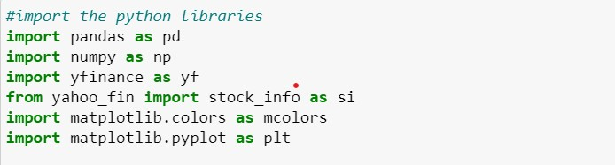 1. Importing python libraries

**Step 2: -**

* 1. Selecting stocks which are to be studied.
  2. Adding number of stocks to the portfolio.
  3. 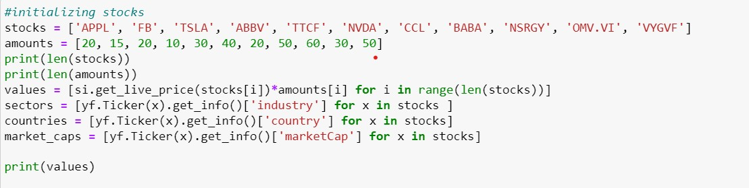Diversification of stocks.

### Step 3: -

1. Selecting Exchange trade funds (EFTS) which are to be studied.
2. Adding number of EFTS to the portfolio.
3. Diversification of EFTS

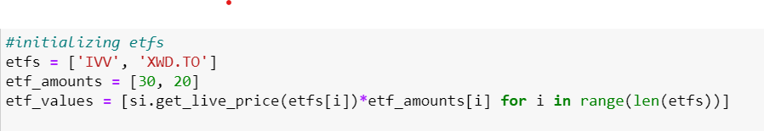

### Step 4: -

1. Selecting Exchange trade funds (EFTS) which are to be studied.
2. Adding number of EFTS to the portfolio.
3. Diversification of EFTS.

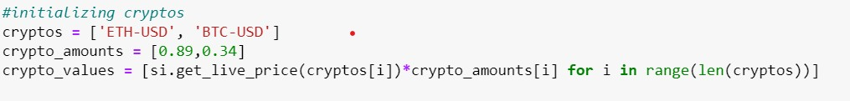

### Step 5: -

1. General distribution of stocks, EFTS, Cryptos, cash.
2. Distribution of sectors.
3. Distribution of country.

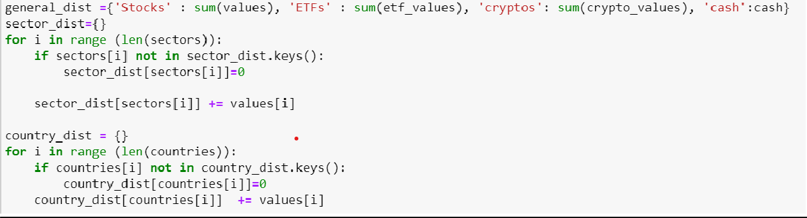

### Step 6: -

1. Market cap distribution.
2. Analyzing the market capacity of different Stocks, EFTS, Cryptos.

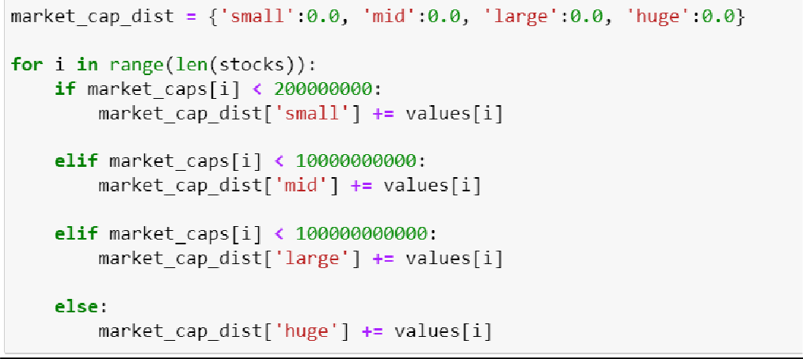

**Step 7: -**

Plotting graph of general distribution.

Plotting graph of sector/industry distribution.

Plotting graph of country distribution.

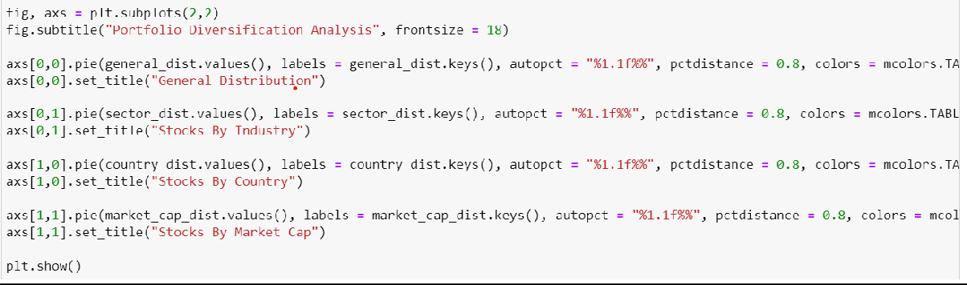Plotting graph of market capital distribution.

**OUTPUTS:**

1. **General Distribution of stocks:**

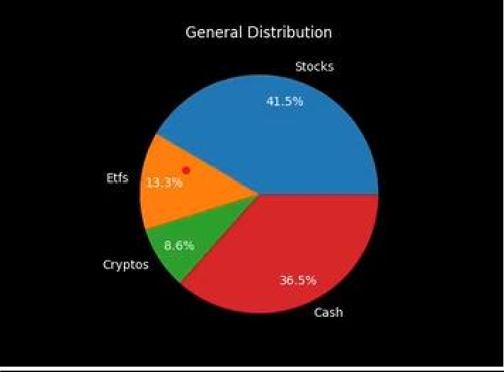

1. **Sector/Industry Distribution of stocks:**

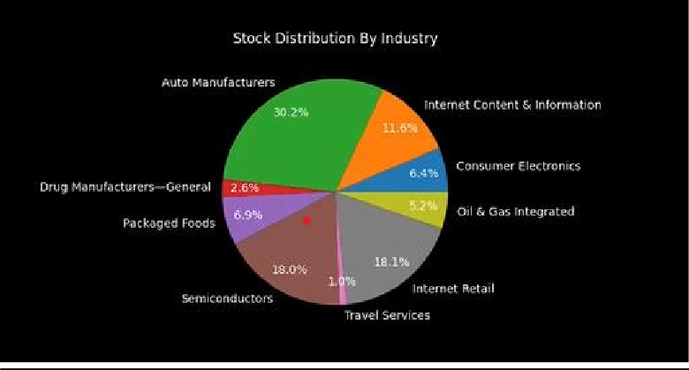

1. **Country Distribution of stocks:**

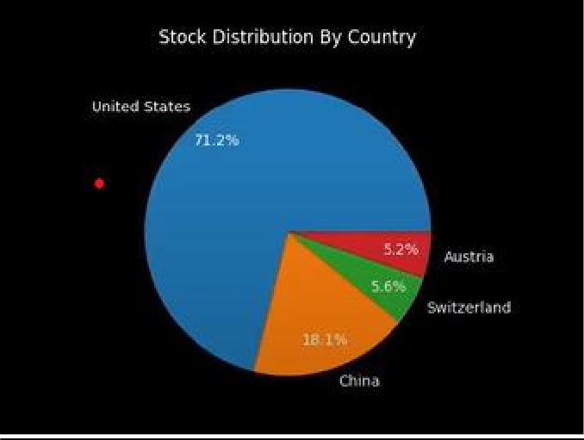

1. **Market cap distribution of stocks:**

### 

### Results

The result of stock portfolio performance optimization is typically a portfolio that maximizes expected return given a level of risk tolerance. The optimized portfolio composition and asset allocation will depend on the specific optimization approach used, as well as the data and constraints incorporated into the optimization model.

The performance of the optimized portfolio can be evaluated using various metrics, such as the Sharpe ratio, Information ratio, or Jensen's alpha. These metrics compare the portfolio's performance to a benchmark and help evaluate whether the portfolio is achieving its objectives.

It is important to note that the performance of the optimized portfolio may vary over time due to changes in market conditions, economic factors, or other unforeseen events.

Therefore, monitoring the portfolio's performance over time and periodically rebalancing the portfolio to maintain its optimal composition is critical to achieving long-term performance objectives.

In addition to evaluating the performance of the optimized portfolio using performance metrics, it is important to also consider the level of risk associated with the portfolio. Risk can be measured using metrics such as volatility or Value-at-Risk (VaR) and should be considered when selecting an optimization approach and setting the risk tolerance level.

Another important aspect to consider when evaluating the results of stock portfolio performance optimization is the impact of transaction costs and taxes. These costs can significantly affect the overall performance of the portfolio and should be considered when constructing and implementing the optimized portfolio.

It is also important to consider the robustness of the optimized portfolio to changes in the input parameters or underlying assumptions of the optimization model. Conducting sensitivity analysis and stress testing can help identify potential weaknesses in the optimization results and enable adjustments to be made to improve the robustness of the portfolio.

Overall, the results of stock portfolio performance optimization should be evaluated based on the specific objectives of the portfolio, the level of risk associated with the portfolio, and the impact of transaction costs and taxes.

**Conclusion**

In conclusion, stock portfolio performance optimization is a critical process for investors who seek to achieve their financial objectives while managing risk. The optimization process involves collecting data on historical asset prices, returns, and other relevant metrics, assessing the risk of each asset, constructing an optimization model, and evaluating the performance of the optimized portfolio Various optimization models can be used, such as mean-variance optimization, CVaR optimization, or robust optimization. The choice of the optimization approach depends on the specific objectives of the portfolio, the level of risk tolerance, and the available data.

Once the optimized portfolio is constructed and implemented, it's important to monitor its performance over time and periodically rebalance the portfolio to maintain its optimal composition. . The performance of the optimized portfolio should be evaluated based on

various metrics, such as the Sharpe ratio, Information ratio, or Jensen's alpha, as well as the level of risk associated with the portfolio.

In conclusion, stock portfolio performance optimization is a complex process that requires expertise in quantitative finance, mathematics, and programming. Therefore, consulting with experts or using specialized software and tools is recommended to ensure that the optimization process is accurate, efficient, and effective in achieving the desired financial objectives.

**Reference**

1. "Mean-Variance Portfolio Optimization: A Review" by Andrés M. Carvajal and Juan C. Vera-Delgado Reference: Carvajal, A. M., & Vera-Delgado, J. C. (2021). Mean- Variance Portfolio Optimization: A Review. Journal of Risk and Financial Management, 14(3), 115.
2. "A Comprehensive Review of Portfolio Optimization Techniques" by Mahdi Kazemi and Omid Dehzangi Reference: Kazemi, M., & Dehzangi, O. (2017). A Comprehensive Review of Portfolio Optimization Techniques. Journal of Financial Research, 7(1), 45- 64.
3. "Robust Portfolio Optimization with Transaction Costs" by Robert J. Vanderbei and Yinyu Ye Reference: Vanderbei, R. J., & Ye, Y. (2014). Robust Portfolio Optimization with Transaction Costs. Annals of Operations Research, 220(1), 381-395.
4. "Portfolio Optimization with Conditional Value-at-Risk Objective and Constraints" by Ataollah Askari Majdabadi and Mehdi Toloo Reference: Askari Majdabadi, A., & Toloo, M. (2021). Portfolio Optimization with Conditional Value-at-Risk Objective and Constraints. Journal of Optimization in Industrial Engineering, 14(1), 1-8.